STEPS FOR WORKAROUND TROUBLESHOOTING:

This document is prepared for the aim of restoring 3rd Party Services when AG is misbehaving as a workaround.

**Login to backend Application server (41.222.176.143)**

1. Check for Disk space: ensure each Path threshold should be less than 85%

Use Command: df -h

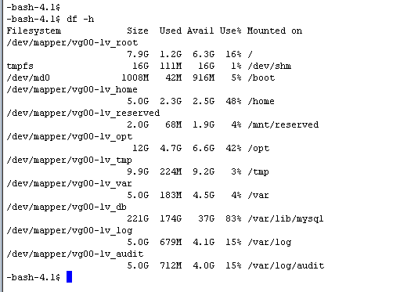

1. check if gateway ssg service is running:

use command: service ssg status

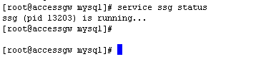

1. check if MySQL service is Running:

use command: /etc/init.d/mysql status

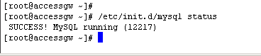

**RESTART SERVICES:**

1. restart ssg service: use command: service ssg restart

Then check service status as Per Pont number: 1 above

1. Restart MySQL service use command: /etc/init.d/mysql restart

Then check service status as Per Pont number: 3 above

**login to external DB server logs (41.222.176.201)-RDP use domain credentials.**

1. Restart MySQL service

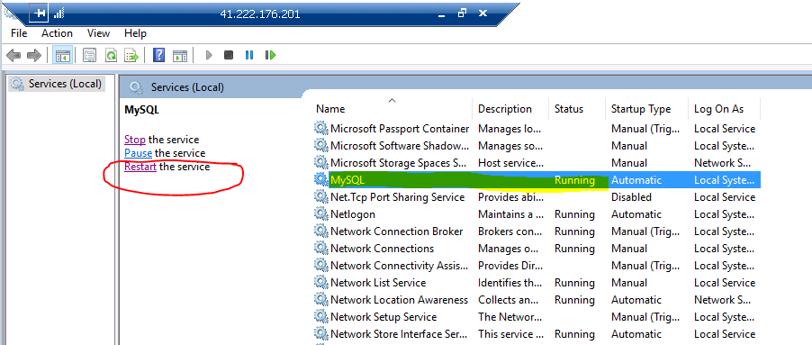

**TO REFRESH MFS APP PROFILE:**

Login to CA portal (policy Manager)

Disable And enable the **/PesaLiveRegisterHE**\* profile.

Steps:

1. Search and select that particular service.

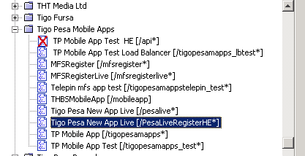

1. Right Click then select service Properties.

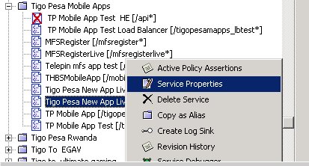

1. Click Disable Radio Button then OK

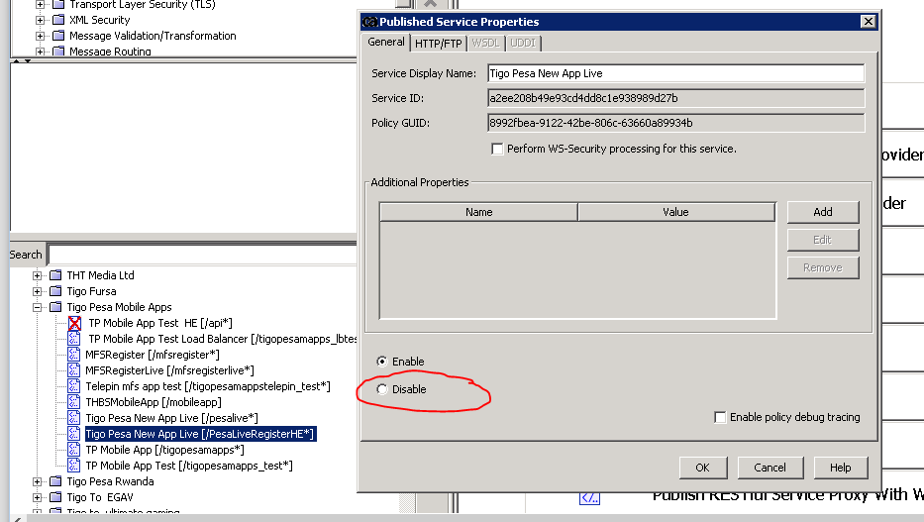

1. Then Enable Again the service and Click OK.